Health & Social Care Domain Scope & Objectives Definition Document
Domain: Health & Social Care
Business Area: Community Care
Release/MiM: 2008b / MiM 7.X

Amendment History:
Version | Date | Amendment History
0.1 | April 2007 | First draft for comment within project Team
0.2 | 11/05/2007 | Circulated for comments to practitioners involved in analysis validation meetings.
0.3 | 14/06/2007 | Updated re: comments received and in-line with other analysis deliverables
0.4 | 25/06/2007 | Updated re: JH comments to CL amendments
0.5 | 18/02/2008 | Updated with RT and RD comments and regarding completion of Messaging analysis for CAF interactions

Forecast Changes:
Anticipated Change | When
Update following completion of deliverables at Scoping Phase | June 2007
Update following completion of deliverables for CAF message development phase | Feb 2008
Update following completion of deliverables at additional interaction analysis Phase | June 2008

Reviewers:
This document must be reviewed by the following. Indicate any delegation for sign off.
Name | Signature | Title / Responsibility | Date | Version
Jan Hoogewerf (JH) |  | Project Manager | June 2007 | 0.3
Christina Lovelock (CL) |  | Business Analyst | April 2007 | 0.1
Practitioners involved in analysis validation |  |  | May 2007 | 0.2
Rod Tooher (RT) |  | Social Care IG Policy | June 2007 | 0.4
Ross Dixon (RD) |  | Senior Business Architect | June 2007 | 0.4

Approvals:
This document requires the following approvals:
Name | Signature | Title / Responsibility | Date | Version
Jeremy Thorp |  | Director of Business Requirements & Project SRO
Ken Lunn |  | Head of Communications and Messaging
Paul Jones |  | CTO
Phil Clayton |  | TO Programme Manager
Ross Dixon |  | Senior Business Architect
tbc |  | ESCR Board

Distribution:
<Document text>.
Document Status:
This is a controlled document.
This document version is only valid at the time it is retrieved from controlled filestore, after which a new approved version will replace it.
On receipt of a new issue, please destroy all previous issues (unless a specified earlier issue is baselined for use throughout the programme).

Related Documents:
These documents will provide additional information.

Ref no | Doc Reference Number | Title | Version
1 | NPFIT-SHR-MODL-GUID-0014.04 | Analysis Authoring Guide | 1.0
2 |  | Message Implementation Manual (MiM) | 7.1
3 | NPFIT-SHR-MODL-HSC-0003 | Analysis Artefact Checklist | 0.1
4 | NPFIT-SHR-MODL-HSC-0005 | Health & Social Care Analysis Model | 1.0
5 | NPFIT-SHR-MODL-HSC-0026 | Portfolio Submission for Health & Social Care Project | 1.0
6 | NPFIT-SHR-MODL-HSC-0002 | Project Initiation Document | 1.0
7 | NPFIT-SHR-MODL-HSC-0027 | SAP Do Once and Share process models | 2006
8 | NPFIT-FNT-TO-DPM-0673 | HSC-SOR-003 Statement of Requirements for enhanced demographics re Health & Social Care | 1.0
10 | ISBN: 0101673728 series number: Cm 6737 | White Paper: Our Health, Our Care, Our Say | Feb 07
11 | Ref not available at this time | Health & Social Care Integration Architecture
12 | NPFIT-SHR-MODL-HSC-0025 | HealthSpace areas for Exploration | 0.2
13 | NPFIT-SHR-MODL-HSC-0016 | Health & Social Care Code Subset Requirements | 0.2
14 | NPFIT-SHR-MODL-HSC-0020 | CAF Information Set (Note this draft document is owned by DH, but is held on FileCM pending policy publication) | 2.0

Glossary of Terms:
List any new terms created in this document. Mail the NPO Quality Manager to have these included in the master glossary above [1].
Term | Acronym | Definition
Common Assessment Framework | CAF | DH policy under development for all ADULT groups  CAF builds on the principles of SAP, covers both assessment and care planning, and applicable for all adult groups, including older people, Learning Disabilities, Mental Health etc.
Carer |  | A carer is a person (usually a friend or family member) that provides regular and substantive care to an individual. N.B this term is NOT applied to paid/voluntary support workers.
Care Management |  | These are the processes undertaken when an individual’s care needs are assessed and appropriate services are provided. Care management includes: making available information about possible help; determining the level of assessment to be undertaken once a person has been referred to the service; assessing their needs; developing a care plan and a care package to meet their needs; implementing the care plan; and monitoring and reviewing the care plan.
Care/ Support Plan |  | A document detailing the agreed actions/ services/ treatment/ care/ support that will be provided to support the needs identified during assessment.
Council with Social Services Responsibilities | CSSR | Local Authority with statutory responsibility to provide social care services.
Department for Children, Schools and Families (Previously Department for Education and Skills) | DCSF (DCSF) | The lead policy agency for integrated children’s information systems across health, education, social care and other agencies. (NB Children’s health records will be held within NHS CRS and are under the remit of the Department of Health)
(MiM) Domain |  | Is part of the MiM representing a coherent part of healthcare or associated administrative functions, which has its own collection of messages. Generally, a domain is too large to be modelled by a single analysis artefact set and so full coverage requires decomposition into multiple models. Each model may be further identified and classified based on the Business Area to which it relates
(CAF) Domain |  | A high level area of well-being which relates to one of the Outcomes for Adults identified in White Paper: Our Health, Our Care, Our Say
Electronic Social Care Record | ESCR | Policy Initiative from Department of Health which should enable the electronic capture and storage of structured, unstructured and coded data from social care records within Local Authorities.
Fair Access to Care Services | FACS | Eligibility criteria, used by Social Services Departments to determine whether a person is eligible for services provided by them. The framework is based on an individual’s needs and associated risks to independence, and includes four eligibility bands - critical, substantial, moderate and low.
Health and Social Care | HSC | The care and support services that provide care for those who have short or long-term ongoing needs. For the purpose of this project this is limited at this time to the Statutory services provided or commissioned by the NHS and CSSRs
Holistic Assessment |  | An assessment which considers the person, their situation and needs in the entirety and is not limited in focus by service type or specialty.
Message Implementation Manual | MiM | This is a document that provides the formal and contractual deliverables to which system suppliers and implementations must adhere. It is published in major releases with sub-releases in between e.g. MiM version 6.1
Single Assessment Process | SAP | Introduced in the NSF for older people; aims to make sure older people's care needs are assessed thoroughly and accurately in a person-centred way, but without procedures being needlessly duplicated by different agencies.

Contents
1. Purpose 7
2. Significant Changes from Previous Versions 7
3. Introduction 7
3.1. Domain/ Business Area Description 7
3.1.1. Service Configurations 7
3.1.2. Care Approaches & Information Processes 8
3.1.3. Health & Social Care for Children 9
3.1.4. Transition from Child to Adult Health & Social Care 10
3.2. Domain Objectives & Predicted Benefits 11
3.2.1. Domain Objectives 11
3.2.2. Supporting the DH CAF Collaborative in the development of an Information Set & associated Guidance as well as supporting the testing / piloting and implementation phases of this work 11
3.2.3. Identify the Information sharing needs for Adult Health & Social Care beyond the CAF: 11
3.2.4. Determine the potential for the integration of Children’s Health & Social Care Information within NHS CRS 11
3.2.5. Benefits of integrated Health & Social Care information sharing 12
3.3. Domain Analysis Requirements 12
3.4. Source of Requirements 12
3.4.1. Commissioning the Domain 12
3.4.2. OBS References 13
3.4.3. Existing Analysis Artefacts 13
3.5. Recommendations for work to be taken forward from Scoping 13
3.5.1. CAF Information Set 13
3.5.2. Coding requirements to support CAF 16
3.5.3. Health & Social Care Information Requirements beyond CAF 16
3.5.4. Enhanced Demographic / Biographic Information (see interaction reference 05 in CAF table above) 17
4. Analysis Scope Definition 18
4.1. Overview of Business Process 18
4.2. Impacted Users 18
4.2.1. Stakeholders 18
4.3. Start/End Points of the Analysis 19
4.4. Out of Scope Activities 19
4.4.1. Domain Specific Processes Excluded from Scope 19
4.4.2. ‘Common Processes’ Excluded from Scope 20
4.5. Exception Conditions to be Included/Excluded from the Analysis 20
4.5.1. Explicit Exception Conditions 21
4.5.2. Assumed Exception Conditions 21
5. Constraints to be taken into Account during Analysis 21
5.1. Applicable Legislation and/or Policy 21
5.2. Volumetrics 23
5.2.1. Performance 23
5.2.2. Resilience 23
5.2.3. Reliability 24
5.2.4. Usage Numbers 24
5.3. Security Considerations 24
5.4. Legacy Systems Considerations 24
5.5. Implementation Considerations 24
6. Assumptions 24
6.1. User Assumptions 25
6.2. System Assumptions 25
6.3. Communication Assumptions 25
7. Relationships to Other Major Business Processes 26
8. Planned Analysis Artefacts 26
9. Phasing Statement 30
10. Backward Compatibility 30
11. Project Governance & Document Control 30
11.1. Project Governance 30
11.2. Owner 30
11.3. Custodian 31
12. Appendix 1.0 - Stake holders 32
12.1. Children’s Services 32
12.1.1. Contact Point 32
12.1.2. Children’s Integrated System 32
12.1.3. eCAF 32
12.2. Reference Group Membership 32
13. Appendix 2.0 - Workshop Outputs 33

Index of Tables
Table 1: Health & Social Care Information Requirements for CAF 15
Table 2: Health & Social Care Information Requirements beyond CAF 16
Table 3: Volumes 23
Table 4: artefacts to be produced with corresponding review/approval requirements 27
Table 5: composition of review / approval boards 28

Purpose
The purpose of this document is to provide the necessary background information required to determine the scope of the analysis products that are to be created for the Health & Social Care Domain (see (MiM) Domain.
That information includes:
- Statement of domain business aims and objectives, including the business needs, problems to be solved and an outline of the benefits to be delivered
- Identification of which analysis artefacts are required for this project
- Scope for each of the analysis artefacts identified
- Assumptions to be made in producing the artefacts
- Control arrangements in terms of governance, ownership and custodianship
This project aims to define requirements to support closer integration, through information sharing, between Health & Social Care services in England. At the conclusion of the Scoping Phase this document will outline the recommended aspects for further analysis.

Significant Changes from Previous Versions
‘Source’ Version | ‘Changed’ Version | Change Description
 | 0.1 | First early draft for internal project review
0.1 | 0.2 | Second Draft following internal team review
0.2 | 0.3 | §3.5 Addition of CAF and other HSC interactions identified.
0.4 | 0.5 | Updates following development of CAF Messages

Introduction
In October 2006 a project to define the Health & Social Care Integration Domain Scoping Project came out of the amalgamation of two projects; the eSAP project and the NHS CRS Health & Social Care portfolio submission. See §3.4.1

Domain/ Business Area Description
The term Health & Social Care describes a range of care or support activities that a person may require if they have on-going needs (e.g. a short or long-term condition or disability) requiring input from health and / or social care practitioners. For the purpose of this project this is limited at this time to the statutory services arranged or commissioned by the NHS and Councils with Social Services Responsibilities (CSSRs)

Service Configurations
Health & Social Care organisations each have their own specific areas of core responsibility, however depending on local priorities and configurations some aspects of service delivery may be provided by either or both organisations. Sometimes services work directly in partnership with each other and have joint funding as well as governance arrangements. The range of services available in any one area is dependent upon local policies, service commissioning and funding.
These services may be delivered by both statutory as well as non-statutory organisations. The touchpoints between organisations / practitioners and how information-flows support consistent and coordinated care are therefore important to supporting the perception of a seamless service by the person being cared for.
A wide range of services are available for Adults with Health & Social Care needs:
- Health Care services are delivered across a range of settings: Acute and Community; by a range of providers: Hospital Trusts, Primary Care Trusts, Mental Health Trusts and includes a wide range of services including: GPs, District Nursing, Occupational Therapy, Physiotherapy, provision of equipment, Audiology, Continence Services, Psychiatry/Psychology (list not exhaustive)
- Social Care support services including: Social Services, Housing support, Domiciliary Care, Meals services, Carer support, Residential and Day services, Intermediate Care, Occupational Therapy, provision of equipment, Advocacy (list not exhaustive)
Delivery of Health and Social Care services is usually divided into two main categories: Adult’s and Children’s Services, which each have different requirements and are often managed by separate departments. Within Adult Services focused teams also may exist to support those with Disabilities/Long-term conditions, Older People, Mental Health and Learning Disabilities. Other localised specialty teams may also exist.
Access to NHS health services is mostly on the basis of assessed need and availability, whilst access to some aspects of care delivered by Councils with Social Services Responsibilities (CSSRs) also includes eligibility assessments based on level of needs identified and on financial situation of the individual. In most CSSRs a savings ceiling is specified beyond which the person may be advised to commission some services themselves. Where the CSSR commissions services, charges may be made to the user according to local policy. CSSRs also have duties to assess the ability of carers to continue to care, and in some CSSRs elements of the above processes are applied separately to carers themselves. Thus responses to needs are subject to variation due to local policy and resource issues.
For people whose needs are seen as eligible Self-assessment and self-directed care as well as the allocation of individual budgets mean that individuals will increasingly be able to organise the social services which they need as well as having a greater involvement in the decisions about the care they will receive.
Contact with Health & Social Care services may be initiated by a variety of needs and processes and at a variety of entry points. For example (and not exhaustively): A visit to a GP, a self-referral, referral to a service by another practitioner / professional, referral by a relative, friend or neighbour, a visit to an Emergency Department, in anticipation of discharge from hospital following a healthcare event.
The important point here is that it is not the route someone takes into services, but the range of needs they may have at that time are identified or assessed by the various processes available.

Care Approaches & Information Processes
The term often used to define the overall care process within Health & Social Care is Care Management. It is usual for services to assess an individual’s needs and to create a list of actions and events/services which will take place for an individual; these are usually called Care Plans (N.B sometimes known as Support Plans within Social Care).
Many of the terms used to describe care or support processes across Health & Social Care are not fully interchangeable with each other, and often have developed subtly different meanings. This increases the challenge when trying to define a single approach to supporting information processes across both types of organisation.
Most services undertake an Assessment or Screening to define need. The Single Assessment Process (SAP) is the most often used approach for assessing holistic care need across a range of aspects. This has been gradually introduced over the past few years to the point where most areas have now adopted either a manual or electronic SAP process (N.B. SAP is still not used everywhere, its most widespread use is in community health and social services, with particularly low coverage in primary and acute care.
Although locally SAP implementation is based on common principles of holistic, proportionate and person-centred assessment, the tools used differ. SAP Assessments have developed in a variety of different directions depending on the design criteria used to develop each tool. Despite early guidance outlining the aims and areas to be covered, this has led to an increasing diversity between different toolsets. There are upwards of 13 tools in use with 6 of these currently approved for use with Older People. Increasing use is being made of SAP (which was designed for use with Older People) for assessing the needs of all adults, particularly for those with long-term needs / disabilities. Two of the accredited SAP tools are in widespread use – FACE & EasyCare. In addition to the commercially developed tools, many locally defined SAP tools are used, some of which are adaptations of nationally approved tools.
A wide range of Specialist Assessments also exist to support identification of need with respect to specific activities, conditions or focused aspects of meeting need. Some of these Specialist Assessments also capture information about generic care needs (e.g. the recently developed Common Assessment of Supportive & Palliative Care Needs, developed by the Cancer Action Team).
The information from these Assessment / Screening processes feed into the subsequent plans to meet need e.g advice on self care or development of a care or support plan. The plan might be one off provision of equipment or treatment short term therapy or ongoing services, which outlines what will be done, by whom and when. Again these plans may be specific to a service / focused need or holistic in nature.
Where SAP is implemented there is generally also the concept of an integrated or overarching care plan, setting out at a high level, the range of health and social care services to be delivered to support an individual. There are in addition, aspect, condition or service specific care plans, which provide more detailed and specific descriptions. Integrated care/support plans are not widely implemented currently.
More generally, many of the assessment, care/ support planning or management processes at present are applicable only to the organisation or discipline delivering a specific service/ aspect of care to an individual. An increasing number of practitioners recognise the need for co-ordinated assessments as well as an integrated care/ support plans that describe the needs and how they will met across a broad range of generic issues. Additionally, making this available as a resource for all those involved in supporting an individual, to consult is a priority.
The White Paper, Our Health, Our Care, Our Say, sets out a vision of integrated health and social care support for individuals, increasing people’s ability to continue independent living and reducing acute admissions. To support the implementation of more integrated working between health and social care, the Department of Health (DH) is currently supporting the development of a Common Assessment Framework (CAF) and Integrated Health & Social Care Support Plan for Adults in England. (For further details see below at: CAF Information Set )

Health & Social Care for Children
The Scoping Project had as one of its objectives to look at the requirements for integrating Children’s information with the services to be delivered by NHS CRS.
It should be noted that the policy direction for children is similar to that for adults, i.e. multi-disciplinary team support for those with complex needs, assessment, and early intervention.
The main areas examined were:
- The Integrated Children’s System (ICS)
  - The ICS has been developed to improve outcomes for children defined as being in need, under the Children Act 1989.
  - It provides a conceptual framework, a method of practice and a business process to support practitioners and managers in undertaking the key tasks of assessment, planning, intervention and review. As well as developing the specifications and core data requirements for multi-agency working
  - Local Authorities are implementing ICS, either using their existing social care system or a separate ICS application.
- ContactPoint (Formerly known as The Information Sharing Index)
  - Contact Point will be the quick way for a practitioner to find out who else is working with the same child or young person, making it easier to deliver more coordinated support.
  - It will be a basic online directory, available to authorised staff who need it to do their jobs. It is a key part of the Every Child Matters programme to improve outcomes for children. It will do this by providing a resource where individuals and professionals working with a child or young person can indicate that they have information to share or are undertaking some action
  - It is currently the subject of consultation with stakeholders, including NHS CFH.
- The electronic Common Assessment Framework for Children (eCAF)
  - eCAF for Children is essentially a means of capturing issues and comments relating to a child, using a standard form – it would provide an early means of capturing concerns and observations. If the formal decision is taken to place a child on a Child Protection Register, other information processes would take over from eCAF.
  - Specifications have been produced for information systems to support CAF, piloting is underway and a business case being produced for implementation.
- The Wider Health & Social Care information sharing requirements for children’ services beyond the services being covered by DCSF
  - This is to be accommodated by participation in a workshop being held as part of LPfIT (London) to look at these issues for children’s services
Reviewing the above involved a number of meetings with representatives of each of the aspects of work being conducted by the Department for Education and Skills. DCSF have policy responsibility for the implementation of information services to support the care of Children within England. (Details of these meetings are included in Appendix 12.1to support work in the future as may be required).
The services above are each at an early stage of implementation; Because of this it proved difficult to define specific areas in which significant progress towards integration could take place at this time. Systems and services are currently being introduced into Local Authorities. Integration with other services is not part of this phase of the work.
It is expected that further work to look at integration will commence at varying points in the future. We will need to monitor progress to see at what point we can rejoin any discussions and become further involved.

N.B.: We consider this aspect of the work of the project is now complete, and have not outlined any requirements for children’s services in further detail within this document. The following sections will therefore only consider the integration of information for Adults, and children’s services will only be mentioned as they relate to completing the overall remit of the scoping project.

A Child-Health Programme was established within NHS CFH (June 2007) led by Steve Smith (Programme Manager). Steve Smith also has responsibility for the Health & Social Care Integration project - these projects remain separate. Given the current situation with DCSF services we did not feel there were specific pieces of joint work that can be taken forward by the HSCI project..

Transition from Child to Adult Health & Social Care
The transition from Child to Adult Health & Social Care was also examined during this project. At present there is no standard process for passing the care of a young person between child and adult services, each locality and service has its own approach.
Currently at the point where an individual moves from a children’s service to an adult service a discharge or transfer process is completed; this outlines the condition(s), support, care and treatment they had and were receiving and which may need to be continued. The new adult service would then complete its own assessment process (which may be generic and / or specialised in nature).
In some circumstances there may even be no formal hand-over of care because of the lack of equivalence between services for Children and those for Adults with long-term conditions / disabilities (e.g. many individuals with disabilities receive little further help when they turn 18, due to the lack of availability of services for adults with some types of long-term condition / disabilities).
The Department of Health has a number of policy initiatives underway to look at the transition point between child and adult health and social care:
- Transition: getting it right for young people: Improving the transition of young people with long term conditions(browsable version):
- In December 2002 the SDO, part of NHS R&D published: The transition from child to adult health and social care
The diversity of these approaches do not appear to provide clear enough standardisation upon which NHS CFH could define a business requirement. When DCSF and or various policy initiatives have further developed their approaches, a formal transition processes may be defined, but these are unlikely to be within the life of this project.

Domain Objectives & Predicted Benefits

Domain Objectives
The main aim of the project is to support effective integrated working between Health & Social Care through information sharing. To do this the project has a number of different phases.
This scoping phase of the project completed its work in May 2007. The work was focused on delivering the following:

Supporting the DH CAF Collaborative in the development of an Information Set & associated Guidance as well as supporting the testing / piloting and implementation phases of this work
- This will deliver an information set to support holistic needs Assessment as well as an Integrated Health & Social Care / Support Plan
- The work to complete this aspect continued beyond the Scoping Phase to fully defined HL7 v3 messages for inclusion in the appropriate MiM
- See Table 1: Health & Social Care Information Requirements for CAF

Identify the Information sharing needs for Adult Health & Social Care beyond the CAF:
- One aspect of this work was to identify the access requirements for Social Care practitioners into the Health Record as well as health care practitioner’s information requirements from the Social Care Record.
- This was achieved by a number of practitioner workshops around the country, which looked at the wider requirements for all health and social care information sharing.
- See Table 2: Health & Social Care Information Requirements beyond CAF

Determine the potential for the integration of Children’s Health & Social Care Information within NHS CRS
- See comments at §3.1.3 – this work will not be progressed by HSCI project
- Business Requirements team resources have been made available to the Child Health Programme, separately from Health and Social Care Integration.

Benefits of integrated Health & Social Care information sharing
The implementation of electronic information flows between Health & Social Care services and organisations and access by care professionals to a single source of information on holistic assessments and care plans will deliver increased benefits around the co-ordinated care of the individual. Improved information sharing will enable a person’s needs and care/ support plans (including plans for relapses) to be available 24 hrs a day to all those involved in their care, as appropriate, including staff acting in emergency roles making judgements about treatment or admissions.
The individual should also be able to gain access to information about them and therefore become more involved in the decisions about the care they receive. It is expected that the HealthSpace Web-portal could provide citizens with access for to their own Assessments and Care / Support Plans, and as such will need further discussion with the team delivering that service. (In-time it may be possible for an individual to contribute directly to the content of the Health & Social Care information about them, particularly through self-assessment and self-care-coordination).

Domain Analysis Requirements
The range of business activities within the scope of this domain that may require defined communications are as follows (N.B. this list does not define a specific requirement but rather the potential for one, which will be assessed as part of the project):
- CAF for Adults Assessments & Integrated Health & Social Care Support Plans
  - Create and access the outputs of CAF Assessments
  - Create and access the outputs of CAF based Integrated Health & Social Care Support Plans
  - Create and access information about Specialist Assessments (N.B. the detail of Specialist Assessments is outside of the scope of this project)
  - Create and access enhanced / detailed demographic (Biographical) information collected as part of a CAF / IHSCP activity
- Access to other non-CAF Health & Social Care Information
  - e.g. Health & Social Care information held on NHS CRS and ESCR Care Records (including:, details of professionals/organisations involved in providing care, care events and potentially some elements of an individual’s summary care record, such as significant conditions and medication)
  - Definition of appropriate access requirements to this type of information will be needed from this work
  - Primary and Acute health care to Social Care referral information
  - Community Care Act (CCA 2003) Discharge Notifications (Section 2 & Section 5)
- PSIS queries relating to Health & Social Care requirements (These may be fully met by existing PSIS query communications)
  - Defining any amendments / additions to the current set of CRE (Care Record Element) Types for specific use in Health & Social Care
- Access to Health & Social Care information by for individuals and their carers (with consent) via HealthSpace

Source of Requirements

Commissioning the Domain
In October 2006 a project to define the Health & Social Care Integration Domain came out of the amalgamation of two projects into one, as they both aimed to cover much of the same ground:
- The eSAP Project
- An e-SAP project was commissioned by the NPfIT Board at the request of a national SAP Action Team, reporting to the CRDB, to define high level requirements and a technical architecture for implementing integrated IT support across health and social care for the Single Assessment Process. At the end of the first stage of the project, which was positively received by the NPfIT Board, a second stage was defined to develop an implementation plan and business case for implementing the proposed technical architecture.
- NHS CRS Health & Social Care Portfolio Submission
- The successful submission defined a project remit scoping the high-level requirements for the integration of Health & Social Care information within NHS CRS. This arose from representations made to the Technical Office asking it to look at how Social Care information would be made available through NHS CRS. See Ref: Portfolio Submission for Health & Social Care Project.

The combined project was defined in a Project Initiation Document (produced by Jan Hoogewerf - Project Manager) it had a very broad remit defined by three main objectives:
- Support the implementation of the eSAP (electronic Single Assessment Process) which developed into supporting the requirements for the CAF (Common Assessment Framework) for Adults, including validation of the technical architecture and development of an implementation plan and business case.
- Define the scope of any other business requirements beyond CAF within adult Health & Social Care (Note, some example of interactions between Health and Social Care, these fed into further analysis with practitioners and were advanced or discarded as per discussion at interaction workshops)
- Scope integration between the work currently the responsibility of the Department for Education and Skills (DCSF) and NHS CFH regarding Health & Social Care for Children, including: the Children’s Index (now ContactPoint), the Integrated Children’s System and electronic CAF (eCAF) or Children.

OBS References
The following references in the OBS for NHS CRS (formerly ICRS) relate to aspects of Health & Social Care:
- 119 - Social Care
- 104 - Assessment
- 105.10 - Care Planning
- 107.5 - Domiciliary Care Management
- 161 - Mental Health
- 165 - Older people
- 168 - Long Term Conditions

Existing Analysis Artefacts
A W5 outlining requirements for SAP was produced several years ago by the Business Requirements Team (NPFIT-FNT-TO-DPM-0080.03). This information has been reviewed; Due to the extent to which requirements (and artefacts) have moved on since then it has not been possible to reuse the deliverables generated then as a basis for this project.
An NHS CFH Do Once and Share for SAP completed some analysis work in 2005 (See Ref: SAP Do Once and Share process models). The aim of this project was to define best-practice with regards to SAP. This has been reviewed and many aspects of it have been used to support the work of the project, particularly to support the development of the CAF for Adults Information Set. Many of the Practitioners involved in supporting this work have also been able to input into the work of this project.

Recommendations for work to be taken forward from Scoping
This section outlines the recommendations from the Project Team at the conclusion of the Scoping Phase regarding work packages to be taken forward to support the integration of Health & Social Care information.

CAF Information Set
An early objective of this project was to support the Department of Health’s CAF for Adults Collaborative. This aims to deliver an Information Set to support the core information standards around safe and effective exchange of information collected by holistic assessments as well as providing an Integrated Care/Support Plan for all adults with Health & Social Care needs. CAF will cover all adult care including those with Long-term Conditions, Older People, Mental Health, Learning Disabilities etc.
The Information Set will support basic Demographics, Contact / Initial Assessment, Overview / Holistic Assessment and Integrated Care / Support Planning. It should be noted that the NHS number will become the Unique Identifier for CAF, and its use across all organisations solely for care purposes has been clarified and approved by the Department of Health.
The Contact / Initial Assessment will provide a series of prompts to support identification of the need for an Overview / Holistic Assessment around the following areas:
- Functional Impairment
- Physical or Sensory Impairment
- Emotional / Mental Wellbeing
- Social Wellbeing
The Holistic Assessment will be based around the outcomes identified in White Paper: Our Health, Our Care, Our Say
- Improved Physical Health
- Improved Personal Dignity and autonomy
- Freedom from discrimination or harassment
- Improved quality of life
- Making a positive contribution
- Economic well-being
- Exercise of choice and control
Domains within the Overview / Holistic Assessment relate to the Fair Access to Care Services (FACS). These will be further defined by Sub-Domains some of which are aligned to Continuing Care. Guidance for how to use the Information Set will also be included.
CAF will seek to build upon the principles and good practice developed through the use of SAP over the past few years. It should be emphasised that CAF is not seeking to develop a new toolset to replace SAP, rather to define core standards for collection and sharing of care information to support greater integration between Health & Social Care services in the services they deliver.
The CAF Integrated Care and Support Plan is aimed at facilitating the provision of a high-level view across all service-specific care plans in place for an individual. Care Planning is done in a wide variety of ways depending upon the intent for their use. The CAF Overview Care Plan will support the collection of information from a range of Care Planning outputs in a textual and or a structured / componentised format (a component is a repeatable structure allowing all the details relating to a specific aspect of care to be kept together).
The CAF Collaborative as well as a Reference Group have inputted into the development and review of the Information Set (Membership details in Appendix 12.2). This has enabled professionals and practitioners to provide validation of its appropriateness. A formal validation of the information requirements was commissioned by the DH from an independent evaluator. This will validate the information exchange processes from different toolset types into the CAF Information Set format as well as the clinical / practice validity of the outputs in real usage situations.
As part of the Whole Systems Demonstrator Pilots, the transfer of the information in electronic form between systems will be tested during 2008, following the development of HL7 v3 messages. This will initially only look at the transfer of CAF communications on a point-to-point basis with persistence on PSIS at a later date (expected to be possible with the delivery of the 2008b phase of NHS CRS).
The most recent version of the CAF Information Set is version 2.0. See Ref: CAF Information Set (Note this draft document is owned by DH, but is held on FileCM pending policy publication)

It was agreed between NHS CFH and departing DH CAF Policy lead that the Information Set would be frozen at version 2.0 until after the Newham WSD pilot evaluation. As at Feb 2008 this version is awaiting final release with the CAF Policy guidance.
NB There is also a Common Assessment Framework (CAF) for Children; this CAF is a very different product and in its present form not directly compatible with the content or aims of the CAF for Adults.

The interactions which will be taken forward to CAF messaging analysis are listed in Table 1: Health & Social Care Information Requirements for CAF.
Table 1: Health & Social Care Information Requirements for CAF
Ref | Area | Interaction Description | Proposed method of advancing requirement (as at June 2007) | Update (as at February 2008)
01 | CAF | Contact assessment (sent from one organisation to another directly, and accessible by any interested Health or Social Care practitioner) | Creation of message to support contact assessment content – 2008b MiM release | Created. In MiM 7.1  Contact Assessment - POCD_MT010001UK01 Overview Assessment - POCD_MT010002UK01
02 | CAF | Holistic assessment (accessible by any interested Health or Social Care practitioner) | Creation of message to support holistic assessment content – 2008b MiM release | Created. In MiM 7.1  Overview Assessment - POCD_MT010002UK01
03 | CAF | Integrated Health and Social Care Support Plan (IHSCSP) (accessible by any interested Health or Social Care practitioner, and the service user) | [A] Creation of message to support Integrated Care Plan content - 2008b MiM release  [B] Enabling individual access to their care plan via HealthSpace | [A] Created. In MiM 7.1  Integrated Care and Support Plan - POCD_MT010004UK01  [B] This will be possible when HealthSpace able to query PSIS for any documents held as part of SCR.
04 | CAF | Outcomes of specialist assessments (accessible by any interested Health or social Care practitioner, may be sent directly to requesting practitioner) | Creation of message to support specialist assessment outcome content - 2008b MiM release | Created. In MiM 7.1  Specialist Assessment Outcome - POCD_MT010003UK01
05 | CAF | Extended demographic information such as communication issues/ accommodation situation (accessible by any interested Health or Social Care practitioner) | [A] Creation of message to support extended demographic content - 2008b MiM release  [B] Explore overlap with existing HealthSpace Message  [C] Explore relationship with additional demographics service “indicators” - which is under consideration within NHS CFH Tech Office | [A] Created. In MiM 7.1  Biographic Information - POCD_MT010005UK01  [B] Submission made to HealthSpace Project Board See ref: HealthSpace areas for Exploration. Jan 2008 - still under consideration  [C] Submission was made to PDS, but requirements not progressed. See Ref: NPFIT-FNT-TO-DPM-0673.

Coding requirements to support CAF
The NHS Strategic Coding solution is SNOMED CT. A considerable amount of work has been done during the CAF messaging analysis phase in regard to coding, and the articulation of SNOMED and MIM vocabularies. Some work in this area is still outstanding, and is outlined in the document: Health & Social Care Code Subset Requirements.

Health & Social Care Information Requirements beyond CAF
Beyond CAF for Adults we have also identified potential requirements around a range of other information needs and exchanges between Health & Social Care organisations (see Overview Use Case Model in Health & Social Care Analysis Model). All the entries in Table 2: Health & Social Care Information Requirements beyond CAF are recommended for further analysis after the completion of CAF messaging work.

Table 2: Health & Social Care Information Requirements beyond CAF
Ref | Area | Interaction Description | Proposed method of advancing requirement
06 | Care Record | Shared access to referral outcome summaries.  (Both posting to Summary Care Record and to originating referrer.) | [A] More analysis needed  [B} These may be the same as outcomes of specialist assessment explore overlap with 04 above.
07 | Care Delivery | Shared access to list of names and contact details of practitioners involved with the person (This information should be available to all interested Health and Social Care practitioners) | [A] More analysis needed  [B] Explore overlap with “Professional Relationships” work under consideration within NHS CFH Tech Office
08 | Care Delivery | Admissions notifications (The admission notification that is routinely passed from Hospital to GP is also be passed to Social Care) | Feed into requirements to Admission Notification message under development for 2008b MiM release
09 | Care Delivery | A&E attendance notifications (The attendance notification that is routinely passed from Hospital to GP is also be passed to Social Care) | Feed into requirements to Admission Notification message under development for 2008b MiM release
10 | Care Delivery | Section 2/ Section 5 of Community Care Act Discharge Notifications (Generated by Hospitals, this must be passed to Social Care) | [A] More analysis needed  [B] Explore overlap with Existing Discharge Report message  [C] Engage with DH Policy re longer term direction
11 | Care Delivery | Section 117 of Mental Health Act notifications (Generated by Mental Health Acute services, this must be passed to Social Care) | [A] More analysis needed  [B] Explore overlap with Mental Health message specifications published in 2008B MiM 7.x
12 | Person Details | Shared access to Demographic data (including carer(s) details). (This information should be available to all interested Health and Social Care practitioners). | Social Care systems to complete NHS CRS PDS compliance process
13 | Person Details | Dates of death/ notifications of death (Shared repository of Service User Demographics used by both Health and Social Care) | Social Care systems to complete NHS CRS PDS compliance process
14 | Person Details | Shared access to consent to information sharing status. | [A] More analysis needed. PDS consent flag may only apply to sharing within NHS.  [B] Social Care systems to complete NHS CRS PDS compliance process.
15 | Care Record | Access to medical history, current diagnosis, list of medications (Information as recorded by GP available to Social Care) | [A] More analysis needed  [B] Engagement with GP Summary Programme to enable roll out to Social Care practitioners.
16 | Care Record | Access to Continuing Care Assessment (Assessment Documentation created by Health Care practitioner also provided to Social care) | [A] More analysis needed
17 | Care Delivery | Access to Social Care Care plan, including service time-table (Care plan created by Social Care made available to Health Care Practitioners) | [A] More analysis needed  [B] Use of Integrated care and support plan as discipline specific care plan, e.g. where social care only support.
18 | Risk | Shared access to Risk and warning indicators with contact details of relevant practitioner | [A] More analysis needed  [B] Explore existing work (e.g. Violent Patient Indicator) within NHS CFH

Enhanced Demographic / Biographic Information (see interaction reference 05 in CAF table above)
An area in which analysis may deliver a valuable understanding is around the management of enhanced demographic information (also called: biographical). This information currently has the potential to be collected by several organisations, from various sources at any time, repeated in a variety of assessment outputs and communications and may also be updateable at any time (e.g. a patient / clients housing, financial situation, home circumstances and employment / training needs etc - list not exhaustive).
A single or unified approach to the gathering, compiling and rendering of biographical information is needed. This is especially important around making the most up to date version of any information available without duplication. Inappropriate handling of this kind of information could potentially lead to confusion or the risk of unsafe interpretation.
It will also be important to identify where the most up to date and authoritative information may be held by different organisations – this may also apply to any other types of information shared between health & social care, not just for demographics.
Before the scope of PDS release 2008a was finalised, the HSCI team had discussions with the PDS team regarding a number of areas identified as possible inclusions in a potentially expanded service of non-identifier PDS information items. - See (NPFIT-FNT-TO-DPM-0673). The submission was not able to feed into the PDS 2008a scope, and the content of the submission has been modelled as a HL7 CDA message which can be sent point to point and persist on PSIS - see row 5 Table 1: Health & Social Care Information Requirements for CAF

Analysis Scope Definition

Overview of Business Process
The project will scope the requirements for closer integration between the NHS and social care. It will include the definition at a high level of:
- The collection, exchange and retrieval of Health & Social Care information that will generate communications between NHS CRS and Social Care systems
  - Reviewing where the touchpoints and transfers of information about an adult’s care between organisations and systems take place
- Interactions between Health & Social Care for adults around operational (care) purposes including:
  - Contact / Referral
  - Holistic / Specialist Assessment of need
  - Requirements around Care / Support Planning
  - Other information flows to support Health & Social Care processes
- The impact on NHS CRS information governance and technical architecture of integration with social care – this is part of the work being undertaken to define a Technical Architecture for Health & Social Care being led by Nick Schlanker
- Define access requirements for service users and carers for self assessment and care management purposes through consultation with the HealthSpace Team
- Review common or generic information outputs from the various forms of Health & Social Care processes (e.g. CAF for Adults, SAP, CPA, Specialist Assessments etc - list not exhaustive) – to identify where standard approaches to information sharing may support improved integration.

Impacted Users
The outcomes from this project are likely to affect most practitioners that work in areas of Health & Social Care across the NHS and CSSRs, and individuals who are receiving care services from them.
In cases where services delivered across organisations break down, the criticism most often levelled centres around the lack of access to relevant / current information for those involved in delivering care or support. The main impact of delivering Health & Social Care information integration will be an improvement in the availability and accessibility of information to support care delivery. This will lead to better assessment, care planning and coordination, and in-turn to improved outcomes for those with support needs.
Access to Health & Social Care information (via HealthSpace) will improve the knowledge and understanding of individuals and their carers. The ability to contribute to the information processes will enable individuals to have a greater involvement in their own care.

Stakeholders
Health & Social Care encompasses one of the widest ranges of stakeholders. Those receiving support for long-term conditions or disabilities and their carers are potential stakeholders. The range of ‘provider’ stakeholders include Acute, Ambulance, Mental Health and Primary and Community Health Services, Social Care Services delivered by Local Authorities (CSSRs). Also, health and social care services delivered by Voluntary, non-profit and Independent Organisations, these are usually delivered through contract or on behalf of the above.
The Department of Health is the lead Policy body overseeing Health & Social Care for adults.
The companies and organisations that deliver systems, toolsets and software to support Health & Social Care information processes also brings a wider range of potential stakeholders into the sphere of influence from the deliverables that may be developed by this project (e.g. NHS (NASP & LSP) and Social Care information system suppliers and SAP / CAF toolset suppliers etc.).

Start/End Points of the Analysis
The business processes, and their associated information requirements, to be covered by this domain analysis commences within the domain / business area at the point where an individual makes contact with a care practitioner and is perceived to have ongoing care or support needs.
The analysis is to end at the point where care or support from Health & Social Care is no longer required within the domain / business area.
The aim of the project is to understand more clearly the breadth of activities within the domain and where / how information processes may be supported by the development of information sharing communications.

See Overview Business Process Model within Health & Social Care Analysis Model. The start of the care process is the point at which an individual requires an assessment of need for care by a Health and / or Social care organisation. This may take the form of a self-referral, identification of need by use of a self-assessment tool or by referral for assessment from a professional, practitioner or agency. In some situations it may mean transition into adult services from child support services, or also mean emergency / immediate care involvement followed by a more thorough assessment of need when circumstances allow.
Once a package of care is in place there is a process of review by a care manager within Social Care. A social worker’s job is mainly assessment / care planning/ review, with less emphasis on provision or delivery. The process of commissioning support from agencies outside the NHS is less developed in the NHS
Within the NHS practitioners / professionals may be responsible for planning as well as delivering a particular course of care / treatment, or alternatively for just one of these activities (e.g. where a certain grade within district nurse teams assess and devise plans that are followed by more junior staff) Care may be reviewed in a formalised planned way or in an ad-hoc manner during the delivery of a care activity, depending on the outcome of their interventions. Different services will manage care according to local or professional protocols.
The end of the care process for a specific health or social care service is where an individual no longer needs or wants the care or support of that service or organisation, and for which no formal or dependent follow-up activities or monitoring are planned. For many individuals with long-term conditions, disabilities, chronic or terminal illness these processes may not end during their lifetime, and for which they will need continual care input and support.
The project has the remit to provide information to support the decision making / approval process regarding work packages for Health & Social Care integration. The scoping phase of the project has concluded by making recommendations about potential work packages which may be taken forward to message development and publishing in subsequent NHS CFH MiMs - these fall into 2 categories:
- Assessment and Care Planning (CAF) -messages which are part of the MiM 7.X MiM release.
- Interactions Beyond CAF which do not yet have a target MiM release

Out of Scope Activities

Domain Specific Processes Excluded from Scope
It is common practice when developing designs for domains to concentrate on a specific area of the business domain, normally by exclusion of commonly understood areas of processes, functionality or information needs. The following specific areas of the domain under consideration are to be excluded from scope:
- Sharing information for other than care purposes, e.g. criminal justice
- Local Authority to Local Authority transfers of social care records
- Secondary uses of operational information for management purposes, except so far as these are defined by the CAF Collaborative
- Detailed analysis of the processes and information flows. The project will identify the overall scope of interactions and within this the different domains/areas, the priority for each area and the resource requirements for carrying out detailed work in each area
- Social Care information processes e.g. financial or other record keeping, including care / case management processes that generate outputs for which there is no information sharing requirement with or via an NHS CFH system.
- Referrals between Health and Social Care organisations, except where a CAF Contact Assessment or other CAF message is sent point-to-point by way of referral. Referral processes vary tremendously across the country, and even within organisations. The content of referrals also varies greatly, with some services requiring specific information to be included in the referral which they can use to assess priority or appropriateness of the service.
- Workflow. Any workflow requirements/ status tracking will not be considered as they are not currently in scope of NHS CFH national services and will therefore be assumed to be handled by local systems.
- Admission notifications for social care services E.g. admission to urgent respite care. This is considered to be a very small number of interactions compared to the numbers of Health Care admissions. It might be re-considered in the future, but not a priority.
- Full details/content of Risk Assessments as the content is locally defined.
- Full details/content if Specialist Assessments as the content varies greatly and as it is the outcome of the assessment that generally needs to be shared with other professionals.
- Patient Centred diary/ schedule of care - integrated for all health & social care services. This is considered to be a highly complex requirement and will be assumed to be handled by local systems. N.B this could be included textually within the Integrated Care and Support Plan Message, but not in a machine-processable way.
- Register entries. Sharing details of entries on Social Care Statutory Registers (Sensory/ Physical Impairments) and other registers (such as Adult Protection) on a per individual basis. Much variation across country.

‘Common Processes’ Excluded from Scope
Processes common to many domains such as establishing LR and RBAC may not be required to be included within the analysis for a particular domain/sub-set. These exclusions are normally applied to the BPM artefact. The following common activities are deemed to be outside the scope of the proposed analysis:
- Definition of PDS Processes
- Definition of LR or RBAC Processes
- NHS Choose & Book activities
- Aspects of care delivered within primary, acute or specialised healthcare settings that are not affected by or related to activities described by the term Health & Social Care.

Exception Conditions to be Included/Excluded from the Analysis
An exception condition is deemed to be when the process is interrupted. E.g. non receipt of an acknowledgement or any other situation where checks are made and the checks fail. These exceptions can be reflected within several of the analysis artefacts including use cases, as alternative paths, and BPMs.
NB The author of this document may not be aware of some of these conditions prior to analysis work commencing. These may need to be discussed with the ‘Owner’ of the document on an ad hoc basis, and a new version of the scoping document created.
In general, the exception conditions to be explicitly modelled are of the ‘flow failure’ type – i.e. where a flow in the process can fail (such as the non-receipt of an acknowledgement message) NB. This applies only where the prospect of the failure is realistic specific cases of this type of failure are identified in §4.5.1 below.

Explicit Exception Conditions
The following exception conditions are to be included within the scope, but are addresses generically by Error Handling model - addendum to the PSIS Compliance Spec addendum (NPFIT-FNT-TO-TIN-1228)
- Non-receipt of expected acknowledgements or notification messages
- Processes involved in handling of invalid messages associated with the encounter.

Assumed Exception Conditions
The following exception conditions can be excluded from the analysis model(s):
- Non-receipt acknowledgements or notification messages from third party systems not directly part of NHS CRS (i.e. Social Care systems not part of NHS CRS)
  - Except where there is a specific operational requirement to provide notice of these events to third-party systems
- Processes involved in handling of invalid messages associated with the encounter/image reporting in third party systems not directly part of NHS CRS (e.g. Social Care systems not part of NHS CRS)
  - Except where there is a specific operational requirement to provide notice of these events to third-party systems
- Security failures (e.g. failure to create legitimate relationships or grant access)
  - Except where there is a specified Health & Social Care systems requirement to provide notice of these events to third-party systems
- Infrastructure failures
- The death of a patient or self-discharge from any or all of the assessment or care processes, as these can take place at any time during the care process and which causes those processes to be immediately suspended

Constraints to be taken into Account during Analysis
The project will be carried out within the following constraints:
- NHS Connecting for Health standards
- The time available from existing NHS CFH teams or additionally by recompense using the standard fee structure for using external consultants
- The needs and competing demands of other projects for NHS CFH resources
- Availability of business users and domain experts from Health and Social Care organisations.

Applicable Legislation and/or Policy
- The Department of Health has recently re-clarified the approval for the NHS Number to be used as a unique identifier by all organisations supporting the care of the individual, but restricts this for care purposes only
  - (http://www.dh.gov.uk/en/Publicationsandstatistics/Publications/PublicationsPolicyAndGuidance/DH_4006813 ):
  - And: The NHS number is primarily intended for use by all NHS organisations that have a requirement to both hold and pass on individual patient based information. Indeed its introduction was on the basis of it being used solely to support the provision of healthcare. However, the number has a significant role in assisting the co-ordination or transfer of care between organisations outside of the NHS.
    - http://www.dh.gov.uk/prod_consum_dh/groups/dh_digitalassets/@dh/@en/documents/digitalasset/dh_4082923.pdf
- Community Care Act (Various dates and revisions)
  - Community Care (Delayed Discharges etc.) Act 2003 – particularly around Section 2 and 5 relating to discharge into the community from hospital.
    - http://www.opsi.gov.uk/ACTS/acts2003/20030005.htm
- The Mental Health Act 1983 applies to both Adults & Children with Mental health needs (the Mental Health Bill 2006/07 is currently going through its various legislative stages in Parliament).
  - Mental Health Act 1983 - http://www.dh.gov.uk/en/Policyandguidance/Healthandsocialcaretopics/Mentalhealth/DH_4001816
  - Mental Health Bill 2006/2007 - http://www.dh.gov.uk/en/Publicationsandstatistics/DH_063423
- The Mental Capacity Act 2005 applies regarding capacity to consent and issues relating to consent for those adults unable to express this for themselves
  - http://www.dca.gov.uk/menincap/legis.htm
- The White Paper - Our Health, Our Care, Our Say outlines many of the major policy aims to support Health & social care
  - http://www.dh.gov.uk/en/Publicationsandstatistics/Publications/PublicationsPolicyAndGuidance/DH_4127453
  - The CAF Information Set has been developed as a result of recommendations from the White Paper which says:
    - We have already developed a Single Assessment Process for older people’s services. Work is underway to build on this to develop a Common Assessment Framework to ensure less duplication across different agencies and allow people to self-assess where possible. An integrated health and social care information system for shared care is planned as part of the NHS Connecting for Health strategy. It is an essential requirement for effective care co-ordination.
    - Also: To ensure that, ultimately, everyone who requires and wants one has a personal health and social care plan as part of an integrated health and social care.
    - Also: By 2008 we would expect everyone with both long-term health and social care needs to have an integrated care plan if they want one. By 2010 we would expect everyone with a long-term condition to be offered a care plan
(Our Health, Our Care, Our Say - Sections 5.26 & 5.27).
  - The recommendations from the White Paper are the main driver behind the work of the DH CAF Collaborative, with which NHS CFH is actively engaged. This builds on the aims of SAP and will identify a core standard for the gathering and exchange of information for all adults, through development of a National Information Set and guidance for Assessment and Care Planning. This will also provide a basis upon which other specialised assessments or information processes may build their generic information gathering and sharing as appropriate.
  - The Information Set will enable existing SAP Assessment and CAF aligned tools to collect and share information in a standard format. It will do this by mapping the outputs from assessments to the standard headings in the Information Set. This will be a one-way mapping which will also record the context in which the information was collected (Main Headings and original questions asked), to enable those who do not have access to or experience of the original toolset to understand the information collected during a holistic assessment or within an Integrated Health & Social Care / Support Plan.
  - There is also a requirement within the White Paper for an individual to be given a copy of their care plan. Also that there is a target for all those with health and social care needs to be offered an integrated care plan by 2008 and all those with long term conditions to be offered one by 2010.
- The Single Assessment Process (SAP) was developed originally to support the assessment of health & social care needs and 6 toolsets have been approved for use with Older People.
- The Department of Health – Care Services Improvement Partnership (CSIP) has set up the CAF Collaborative (CAF for Adults) to develop and implement a standard Information Set for improved integration of information across Health & Social Care organisations. The NHS CFH Health & Social Care Project Team are working closely with DH to support this development

Volumetrics
The following outlines the potential throughput of messages for Health & Social Care relating to the CAF Information Set (Figures obtained by Jan Hoogewerf – Project Manager. The assessment volumes are based on DH NHS and PSS statistical collections for social services, community nurses and allied health professionals (2004/05), with first contact being used as a proxy for an assessment in the case of community nurses and AHPs where there are no national returns on assessments. The number of integrated care plans is based on the target set for 2010 for all people with long term conditions to be offered an integrated health and social care plan. The figures included in the table below are per annum.
Table 3: Volumes
Message | Number
Assessments | 6043000
Extended demographics | 6043000
Integrated health & social care plans | 15000000
Total | 27086000
N.B More detailed estimates were developed by BT, and included in the 7900 2008-B Volumetric Requirements (REQ060) document.
There would be additional volumes for non-CAF information exchanges and PSIS queries (when H&SC information persists on PSIS).
Also, the recently released 2005-2006 Referrals, Assessments and Packages of Care (RAP) Report includes the following:
1) An estimated 2 million contacts from new clients were made to Councils with Social Services Responsibilities in England in 2005-06, a rise of 79,000 or 4 percent from 2004-05.
2) Of the 2 million referrals, 592,000 (29%) were self-referrals, 495,000 (24%) were referred from Secondary Health sources (e.g. hospital wards), and 281,000 (14%) were referred by family, friends or neighbours. There were 264,000 (13%) referrals from Primary/Community Health.

Performance
There are no statements of performance available to the project at this time – later versions of this document may be able to update this when requirements have been defined further.

Resilience
There are no statements of Resilience available to the project at this time – later versions of this document may be able to update this when requirements have been defined further; however we do not envisage Health & Social Care providing any requirements that are different to those of the rest of NHS CRS at this time.

Reliability
There are no statements of Reliability available to the project at this time – later versions of this document may be able to update this when requirements have been defined further.

Usage Numbers
See statement above at 5.2 for further details.

Security Considerations
The Project will review the Information Governance implications of information exchange across organisational boundaries between Health & Social Care Systems – the specific requirements for this aspect are being dealt with by Nick Schlanker in the Health & Social Care Integration ArchitectureThe areas under consideration relate to access Local Authority systems to NHS CRS as well as establishing conformity for them with PDS access requirements e.g. RBAC, Smart Card Access and LRs
The current approach regarding consent for information sharing within NHS CFH exists at a single consent or dissent level. Other Health & Social Care processes often seek to offer more granular Information Sharing Protocols. It is currently understood that an objection by an individual to sharing information with just one professional or organisation could effectively prevent the sharing of the information with all other organisations.
A protocol for the sharing of information generated by the CAF for Adults Information Set will be part of the guidance being developed by the DH CAF Collaborative, supported by the team from this domain. It is expected that this will require integration for both NHS CRS and Local Authority systems to meet a commonly agreed protocol to enable sharing between systems.
We will need to ensure a clear understanding is available of the implications upon information sharing across Health & Social Care organisations, as well as identifying any areas that may require further action e.g. the implications of refusal to share information.
In its work the NHS CFH Health & Social Care Integration Scoping Project Team will seek at all times to uphold the principles of the Information Sharing Guarantee as defined by the Care Record Development Board (CRDB). It is understood that the board replacing the CRDB will be looking to develop a Social Care Information Sharing Guarantee as part of its work.

Legacy Systems Considerations
The project is working closely with the NHS CFH Existing Systems Programme to identify where existing systems (e.g. social care systems) may impact upon the delivery of Health & Social Care information integration.
One area already identified is supporting the use of existing SAP toolsets, particularly as they evolve to support the CAF Information Set.

Implementation Considerations
Nick Schlanker – Technical Architect for the project has produced a paper outlining the high-level approach to supporting the technical integration aims across Health & Social Care systems See Ref: Health & Social Care Integration ArchitectureOne need already identified is the requirement for Social Care systems to be fully compliant with NHS CFH information governance and PDS foundation modules, and to have received accreditation from NHS CFH, through the National Integration Centre compliance process, prior to enabling access to information being transmitted via TMS or held on the NHS CRS Spine. Social Care system suppliers are being supported in this as part of the work being done in this area by the NHS CRS Existing Systems Programme.
We will also investigate further the implementation of Clinical Spine Application (CSA) to CSSRs, potentially as an interim until social care systems are fully NHS CRS compliant, and have implemented all relevant messages. Currently some Local Authorities use NHS Strategic Tracing Service (NSTS), the functionality of which is being replaced by CSA.

Assumptions
The following assumptions are to be made in undertaking this analysis:
- Information and resources from the existing NHS CFH work-streams will be made available in a timely manner leading to no significant delays in the project
- Significant architectural changes will not be needed by NHS CFH products in order to facilitate closer integration with social care
- The core work of this project is resourced from within existing NHS CFH resources
- Social services and SAP toolset systems suppliers and LA IT leads are available to engage with the project, attend meetings and respond to questions
- NPfIT documentation (such as the foundation module specifications) can be made available to the social services system suppliers
- Existing Systems Programme foundation module compliance specifications do not change significantly for social care systems
- Care Record Element (CRE) Type structure can be added to, to accommodate Social Care information
- NHS CFH Clinical Document Architecture (CDA) templates can be created, to accommodate Social Care information.
- Care practitioners are available on a timely basis to participate in the definition of requirements.

User Assumptions
- The use of the NHS Number as a unique identifier across all organisations and systems for supporting care processes
- All users will be issued with an individual Smart Card, from relevant Registration Authority (RA)

System Assumptions
- All systems involved in Health & Social Care Integration will become NHS CRS compliant
- The system will authenticate the user with the Spine, before allowing access to any Spine application
- Agreement regarding the scope of Information Sharing Protocols and Information Governance standards between health & Social Care systems will be resolved to a workable solution
- All systems will use the information formats approved by the Department of Health as defined by the CAF Information Set. This will include achieving accreditation for compliance with any minimum specifications published with the guidance for use of the CAF for Adults Information Set
  - This may also include any system assumptions or requirements that may be set out in the relevant MiM

Communication Assumptions
- Despite the earlier analysis for SAP there are no pre-existing messages defined for use within NHS CRS;
- For Assessment and Care Plans (CAF), the communications specified in the 7.x series MiM must be used. (see Table 1: Health & Social Care Information Requirements for CAF)
- For integration wider than CAF (see Table 2: Health & Social Care Information Requirements beyond CAF) there may be other existing messages which may be applicable e.g. Discharge messages - this area still to be analysed.

Relationships to Other Major Business Processes
The following boundary business processes are referenced or interacted with from within the scope of this model:
The following boundary business functions are referenced or interacted with from within the scope of this model:
- Personal Demographics Service(PDS)
- Spine Security Broker (SSB)
- Spine Directory of Services (SDS)
- NHS CRS
- External Health & Social Care systems
- HealthSpace

Planned Analysis Artefacts
In addition to this domain scope and objectives definition document the analysis artefacts identified in Table 4 have been created in support of the scope identified above.
Please note that the current status of the artefacts listed here can be found in the Analysis Artefact Checklist
The required review and approval for each of these artefacts is identified in Table 4 and Table 5
The following analysis deliverables were produced during the Scoping Phase based on current Business Requirements Team methodologies (See Ref: Analysis Authoring Guide):
- Domain Scoping Document (i.e. this document)
- Overview Use Case Model
- Overview Business Process Model
- Business Information Model
The following analysis deliverables were produced during the CAF analysis phase:
- Business Process Model
- Detailed Use Case Model
- Scenarios
- Communication Descriptions (x5)
- Information Examples (x8)
- Requirements Catalogue

Artefacts from both phases have been delivered as a single model available in Enterprise Architect native and HTML formats, See Ref: Health & Social Care Analysis Model.

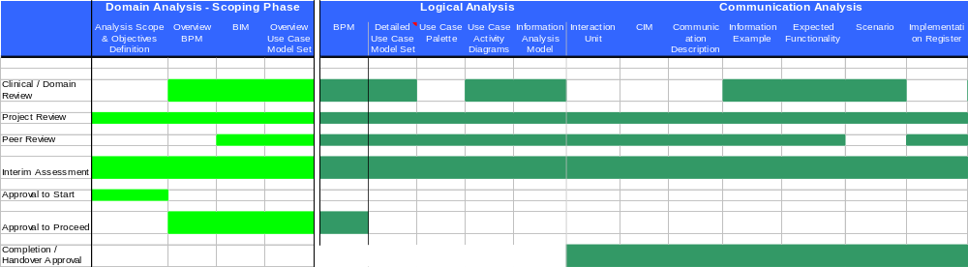
The light green items above define the deliverables to be produced during the Scoping Phase – deliverables after this are only advisory for this domain at this time
Table 4: artefacts to be produced with corresponding review/approval requirements

Review / Approval Category | Review / Approval Board Members
Clinical / Domain Review | HSC Adult Reference Group (Shared membership with DH CAF Collaborative RG)
Project Review | Jan Hoogewerf – Project Manager  Nick Schlanker – Project Technical Architect  Kevin John –Business Analyst HSC Domain  Christina Lovelock – Business Analyst HSC Domain
Peer Review | Tim Pilkington
Interim Assessment | Jan Hoogewerf – Project Manager  Christina Lovelock –Business Analyst HSC Domain  Ross Dixon – Head of Business Requirements Team  Nick Schlanker – Project Technical Architect
Approval to Start | Jeremy Thorp – Director of Business Architecture Requirements  Paul Jones  ESCR Board
Approval to Proceed | Jeremy Thorp – Director of Business Architecture Requirements  Paul Jones  ESCR Board
Completion / Handover Approval | Kenneth Lunn, Richard Kavanagh, Phil Clayton, Paul Jones, Ross Dixon, Steve Smith

Table 5: composition of review / approval boards

Phasing Statement
The CAF messaging requirements have been published in MiM 7.X. For HSCI work other than CAF - a specific MIM version has not yet been finalised.
All analysis work complies with the current Business Requirements Team methodology and deliverables as outlined in (See Ref: Analysis Authoring Guide)

Backward Compatibility
Any new Health & Social Care system which is integrated to a national service, for example PSIS, will need to use the latest version of the domain communications. If a domain communication changes, then any existing Health & Social Care system will need to update its communications to comply with the new requirements, and complete compliance testing to achieve accreditation. New systems sending communications to national services will be expected to support the most recent version of the domain communications.
Existing systems will be expected to support all communications which are current, or no more than one major version behind the current version. Systems receiving communications from national services will be expected to support the most recent version of all communications, and the previous version of the communications. The national services will support the most recent version, and the previous version of the communications. All systems sending or receiving communications to national services will be expected to migrate to the new version over a period of time; typically we would expect no more than two major versions to be supported at any point in time.
Full backward compatibility requirements for this domain are currently unclear due to the wide range of issues covered by the scoping project. However it is not expected that there will be compatibility issues with releases / phases of NHS CRS services prior to the publication of domain artefacts for any identified work packages within Health & Social Care.
It is expected that future releases will need to maintain compatibility for the rendition of any communications exactly as they were when captured, the context applicable at the time. Also, it is expected that full retrieval of Health & Social Care related communications captured over time to the NHS CRS Spine will be a requirement.

Project Governance & Document Control
Due to the history and scope of this project it has its own specific Project Governance arrangements.
This document is to be created by the Custodian of the analysis artefacts. The Owner of this document is responsible for reviewing and authorisation of this document

Project Governance
Governance arrangements for the project are as follows:
- The project will report to the Electronic Social Care Record Implementation Board, which will be responsible for overview of the project and review of deliverables prior to their submission to the National Programme Board.
- Jeremy Thorp was the SRO and Programme Director for the Project during the Scoping Phase; from November 2007 SRO for HSCI domain became Steve Smith
- Deliverables will also be submitted for review to the Care Records Development Board (or its successor) to ensure that they support the wider stakeholder requirements.
- There will be regular project team meetings to co-ordinate the day to day operation of the project and actively manage progress, risks and issues. This process will also manage the escalation of issues to the project board or, if they are urgent, to the SRO

Owner
Jan Hoogewerf (Project Manager) is responsible for the validity of the content of this document.

Custodian
Kevin John and Christina Lovelock are the original document authors; however the maintenance of this document has been handed over to Ursula Green as at February 2008

Appendix 1.0 - Stake holders

Children’s Services
The following meetings were held to define the business needs of children’s services:

Contact Point
- We were not able to arrange a specific meeting regarding this aspect; however DCSF and NHS CRS have had other contacts around ContactPoint – the outcomes of these contacts have been passed onto us and form the basis for not taking this forward at this time.

Children’s Integrated System
- March 2007 Paul Humfryes, DCSF

eCAF
- February 2007 Jayne Horry DCSF, eCAF Project Manager
N.B. To reiterate, because of the findings from these meetings it was decided not to take the description of requirements for Children’s services forward at this time.

Reference Group Membership
The Reference Group included
 | Member | Organisation | Cluster
1 | Adam Paxton | Lincs PCT, GP | East
2 | Bev Castleton | Surrey PCT, Chair of Southern Cluster ERG | South
3 | David Allan-Smith | Essex PCT, Chair of Eastern Cluster ERG | East
4 | David Lyon | Halton PCT, GP | NWWM
5 | David McNally | Trafford PCT, Chair NWWM Cluster ERG | NWWM
6 | Fran Gillet | North West SHA | NWWM
7 | Jane Millar | Information Standards Board | N/A
8 | Keith Strahan | NHS CFH London, Chair London SAP Leads | London
9 | Keri Storey | Devon Social Services | South
10 | Mary Riches | North Lincolnshire PCT, NEYNL SAP Lead | North East
11 | Neil Bartram | North Yorkshire CC Social Services | North East
12 | Peter Ashley | Service user, ESCR Board member | N/A
13 | Richard Allen | Southern Cluster SAP Lead | South
14 | Richard Carthew | NHS CFH London, Mental Health | London
15 | Richard Eccles | CSIP | East
16 | Rod Tooher | DH | N/A
17 | Isobel Frean | Independent Sector: BUPA | N/A
18 | Martin Jones | Arthritis Care UK | N/A
19 | Isobel Warren | SAP Project Manager, East Sussex | South
20 | Sue Barrett | Community Matron, West Sussex PCT | South

Appendix 2.0 - Workshop Outputs

Workshops were held in Cheshire, Solihull, Greenwich and Tower Hamlets with practitioners from a wide range of Health & Social care disciplines. London based workshops were facilitated by BT and LPfIT as part of local integration requirements gathering. Other workshops were arranged solely for input into this scoping work, and were facilitated by Health and Social Care Integration scoping project team. Full Details see Health & Social Care Analysis Model.

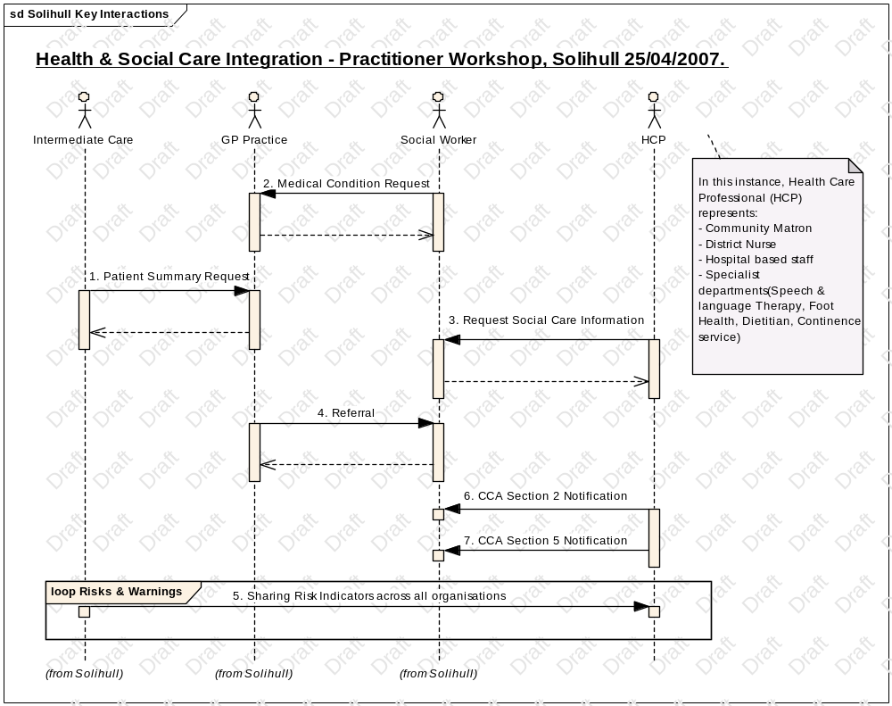

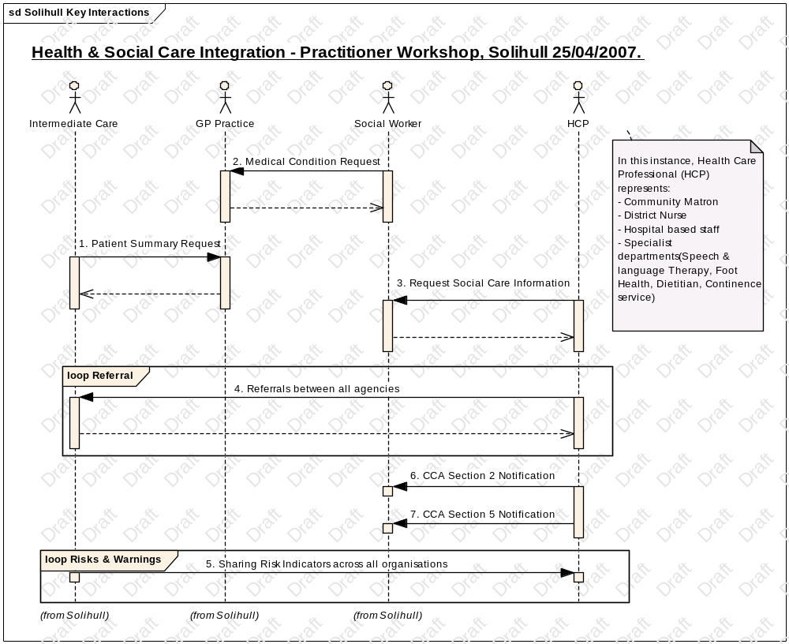

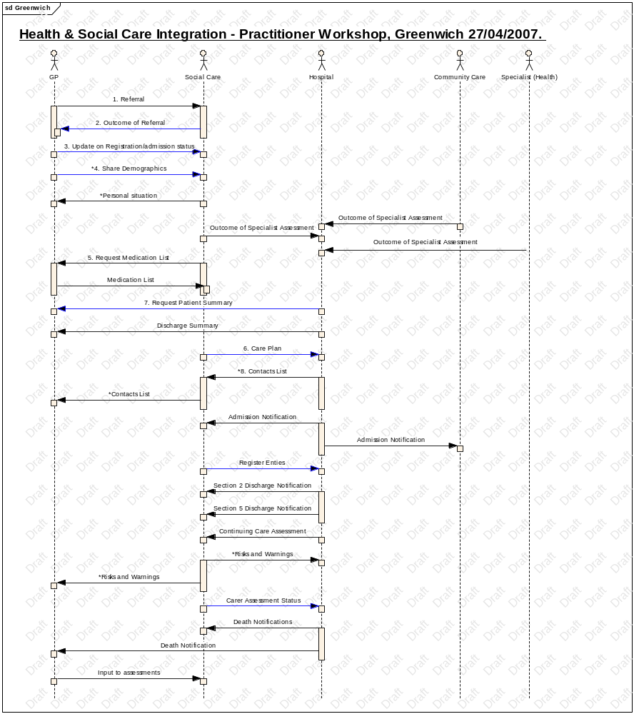

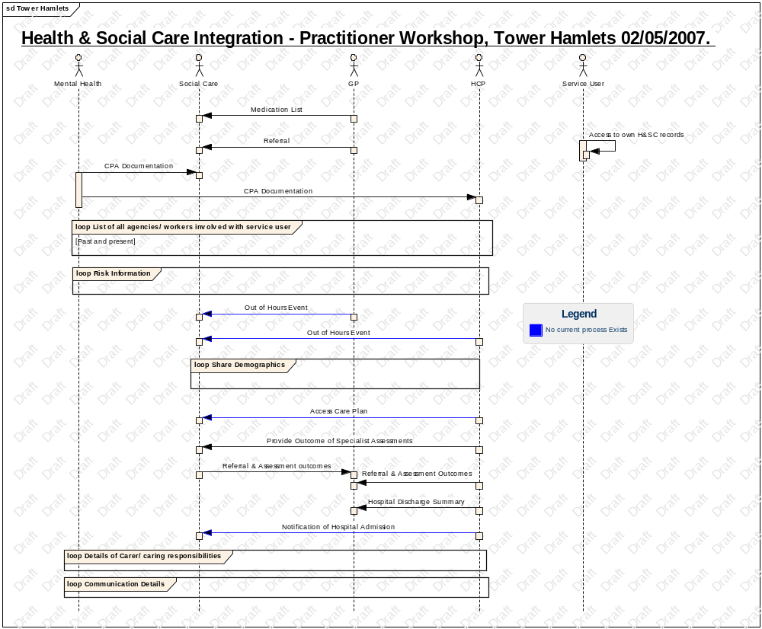

For example Care Trusts http://www.dh.gov.uk/en/Publicationsandstatistics/Publications/PublicationsPolicyAndGuidance/DH_4005188
http://www.dh.gov.uk/en/Policyandguidance/Healthandsocialcaretopics/Socialcare/Singleassessmentprocess/index.htm
http://www.everychildmatters.gov.uk/socialcare/integratedchildrenssystem/about/
http://www.everychildmatters.gov.uk/deliveringservices/contactpoint/about/
http://www.everychildmatters.gov.uk/_files/89A95CE3AC0E8FDDE06F4289C88B19AC.pdf
http://www.dh.gov.uk/en/Policyandguidance/Healthandsocialcaretopics/ChildrenServices/Transitionfromchildrenstoadulthealthservices/index.htm
http://www.dh.gov.uk/en/Publicationsandstatistics/Publications/PublicationsPolicyAndGuidance/Browsable/DH_4132944
http://www.sdo.lshtm.ac.uk/files/adhoc/11-briefing-paper.pdf.
http://www.dh.gov.uk/prod_consum_dh/groups/dh_digitalassets/@dh/@en/documents/digitalasset/dh_4082923.pdf
(http://www.dh.gov.uk/en/Publicationsandstatistics/Publications/PublicationsPolicyAndGuidance/DH_4127453)
http://www.dh.gov.uk/en/Publicationsandstatistics/Publications/PublicationsPolicyAndGuidance/DH_073094
Hazel Qureshi - Initial draft of CAF Information set evaluation report was produced, and commented on by NHS CFH December 2007.
CAF Issues Sign-off from Department of Health: NPFIT-SHR-MODL-HSC-0017.01
Market dominated by 5 suppliers - OLM Systems, Anite, In4tek, Corelogic, CareWorks.
http://www.dh.gov.uk/en/Policyandguidance/Healthandsocialcaretopics/Socialcare/Singleassessmentprocess/index.htm
http://www.socialcare.csip.org.uk/index.cfm?pid=7
http://www.ic.nhs.uk/pubs/rapcssr06/report/file
In fact, NHS CFH approach to CRE model has changed significantly during the analysis for HSCI domain. No new CRE types have been created at this time
12 new NHS CFH CDA templates were created during the analysis for HSCI domain
Policy interpretation of the use of NHS Number by social care has been significantly discussed within NHS CFH and is ongoing.

